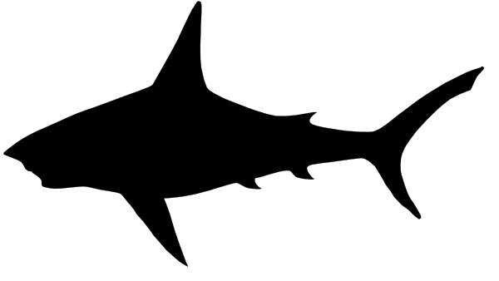

**Warning Shark**

**Territory**