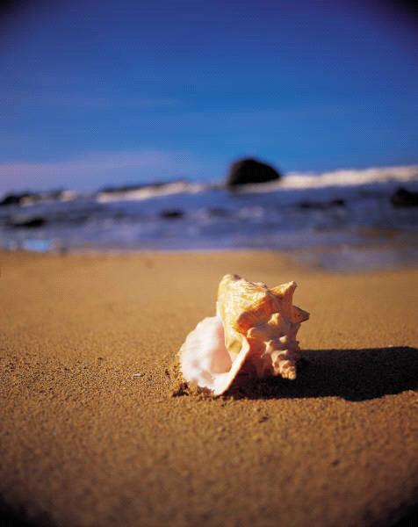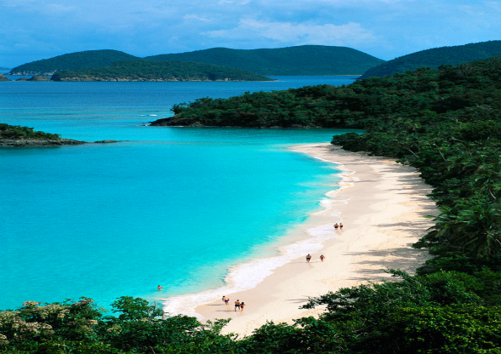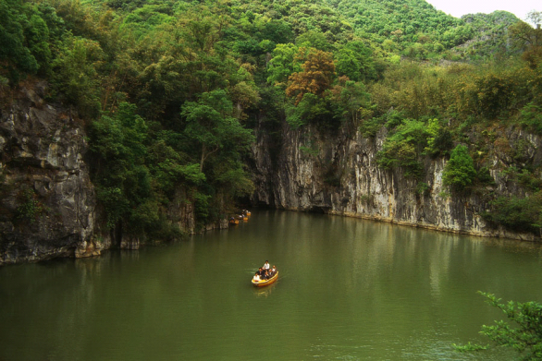

[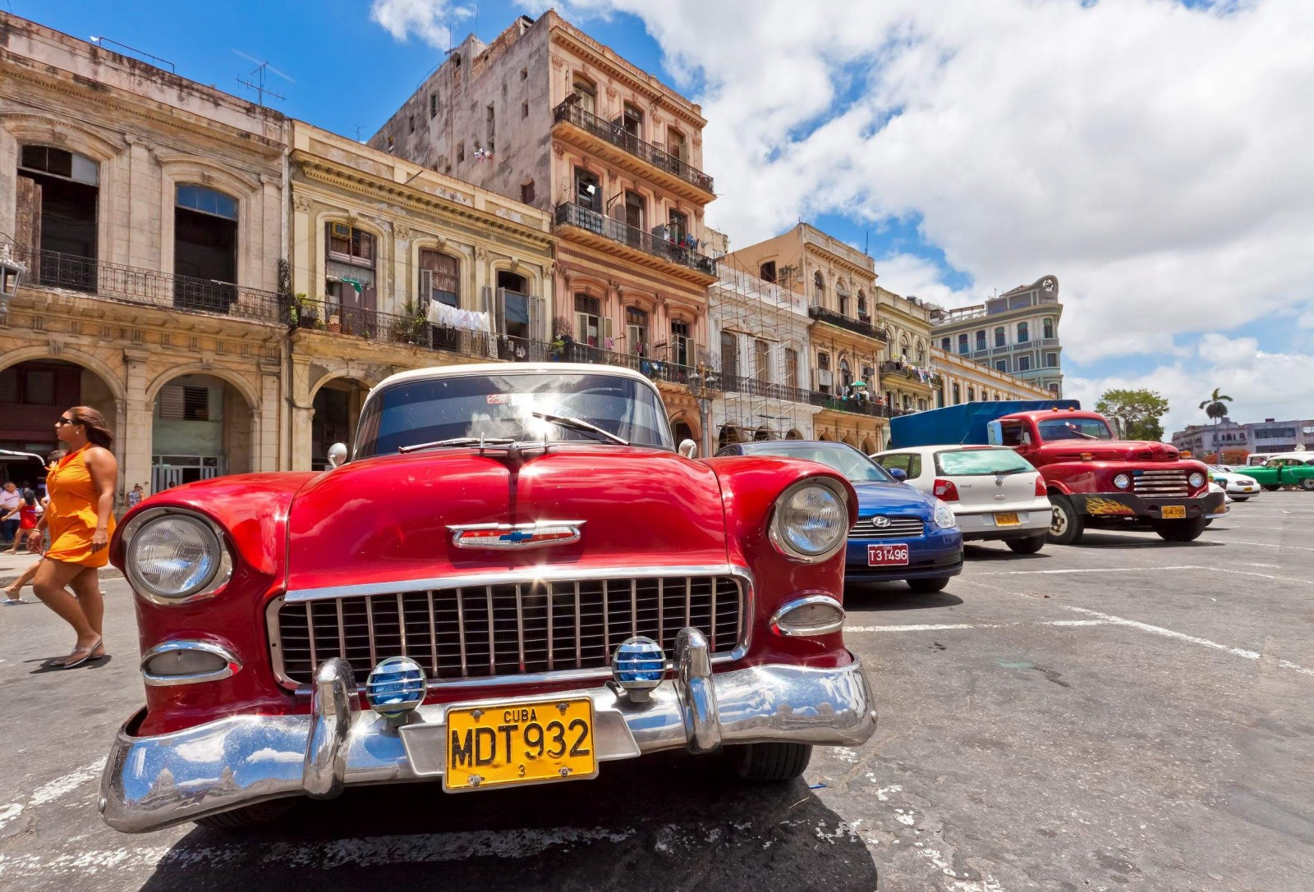](http://www.google.com/url?sa=i&rct=j&q=&esrc=s&frm=1&source=images&cd=&cad=rja&docid=ENY8ujEyJvw6oM&tbnid=qV7LfYmxzwMlkM:&ved=0CAUQjRw&url=http%3A%2F%2Ftravellers-stories.com%2F2013%2F01%2F23%2Fcuba-in-new-zealand-the-famous-cuba-street%2F&ei=deGPUeuFBoGc9gSR-oGoCA&bvm=bv.46340616,d.dmg&psig=AFQjCNGgxKND1T7M745uA8vDzEuq0by33A&ust=1368470238631312)

wildlife. If you are in love with nature this is the place for you. Take a stroll down the beach and experience the nice weather. This is a once in a lifetime opportunity. Please do not miss this chance. You will get an exclusive stay at one of the best hotels, restaurants, and spas. In conclusion, you do not want to miss this chance.

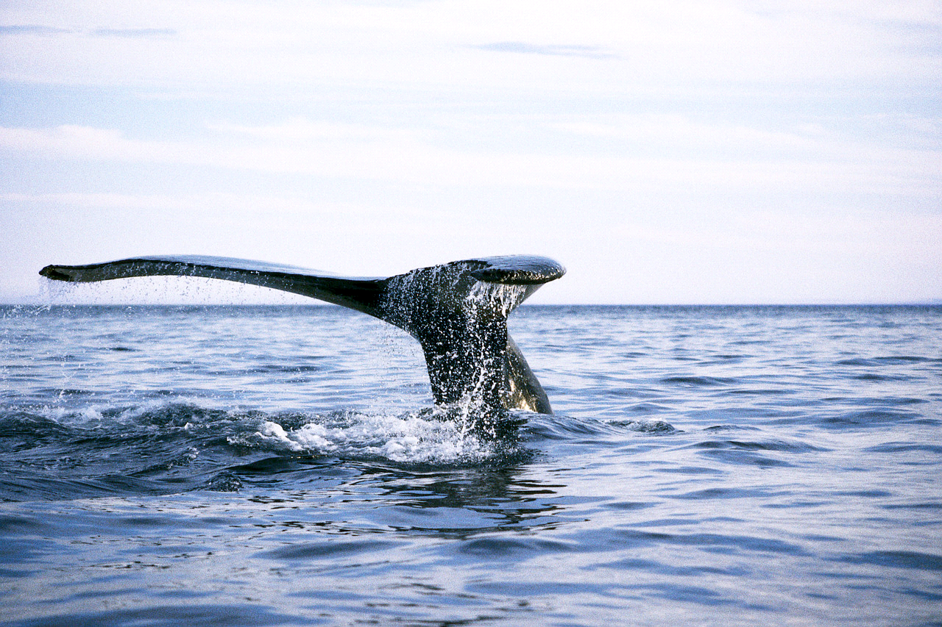

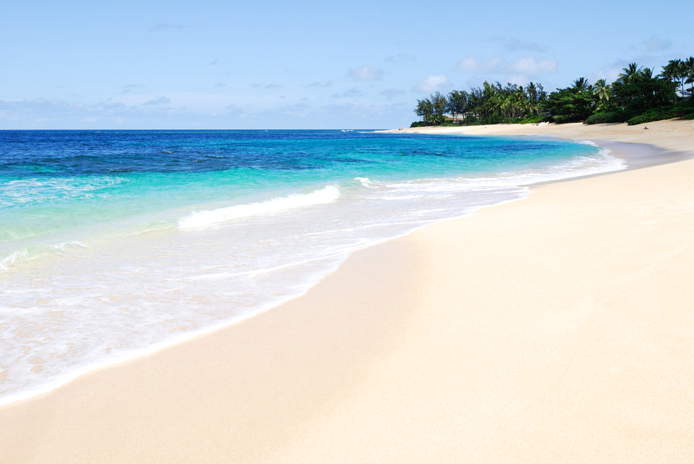

Adventure Works

One Main Street

Las Vegas, NV 89113

Phone (702) 888 8888

Fax (702) 888 8888

<http://www.santiago>andthesea.com

### Adventure Works World TOURS



Our mission is to provide you

the highest quality vacation

you have ever had.

Adventure Works

One Main Street

Las Vegas, NV 89113

Phone (702) 888 8888

Fax (702) 888 8888

<http://www.santiago>andthesea.com

# Cuba

## Memories to last a lifetime

Enjoy the scenic view of Cuba. It has wonderful beaches, resorts, and

A once in a lifetime opportunity!!!

We make you go Round the WORLD

Phone: (702) 888 8888